FAQ FOR PRACTICES

Impacted Practice – FAQs

Who has been impacted:
On Dec 31, Manage My Health became aware of a cyber crime where hackers were able to access and take some documents contained in the “My Health Documents” module of the Manage My Health application.

The documents that they were able to access we now know fall into 2 categories:
Hospital discharge documents from Northland hospitals.
Documents/images uploaded personally by the patient themselves into the ‘My Health Documents Folder’

But previously you said that specialist referrals were also affected?
We originally believed that the hackers had accessed all documents in the My Health Documents folder and its sub-folders. However further forensic investigation has confirmed with certainty that documents held in the Specialist Referrals sub-folder was not accessed or taken by the hackers. This is good news as we have been able to confirm that fewer patients have been impacted.

Some patients were notified that they may have been impacted ( specialist referrals) but we now know that they are not affected. We are directly reaching out to those patients to notify them and to encourage them to open the Manage My Health app to see their updated security status.

Is Manage My Health safe to use, is my PMS safe to use.?
No other part of the application was affected, and we have fixed and tested the My Health Documents module. External cybersecurity experts have now also confirmed that the application is safe and secure and can continue to be used. The PMS and the connection between the PMS and Manage My Health are safe and secure and were not breached by the hackers.

Which patients or documents were compromised?
Practices can check by accessing report 20 in the Provider Portal or refer to the reports that have been shared with them confidentially. Patients who have numbers provided in the Northland and Patient upload columns have been affected. Please note that the specialist referrals documents were not accessed, so no one in that column was affected (unless they also had documents in the other categories).

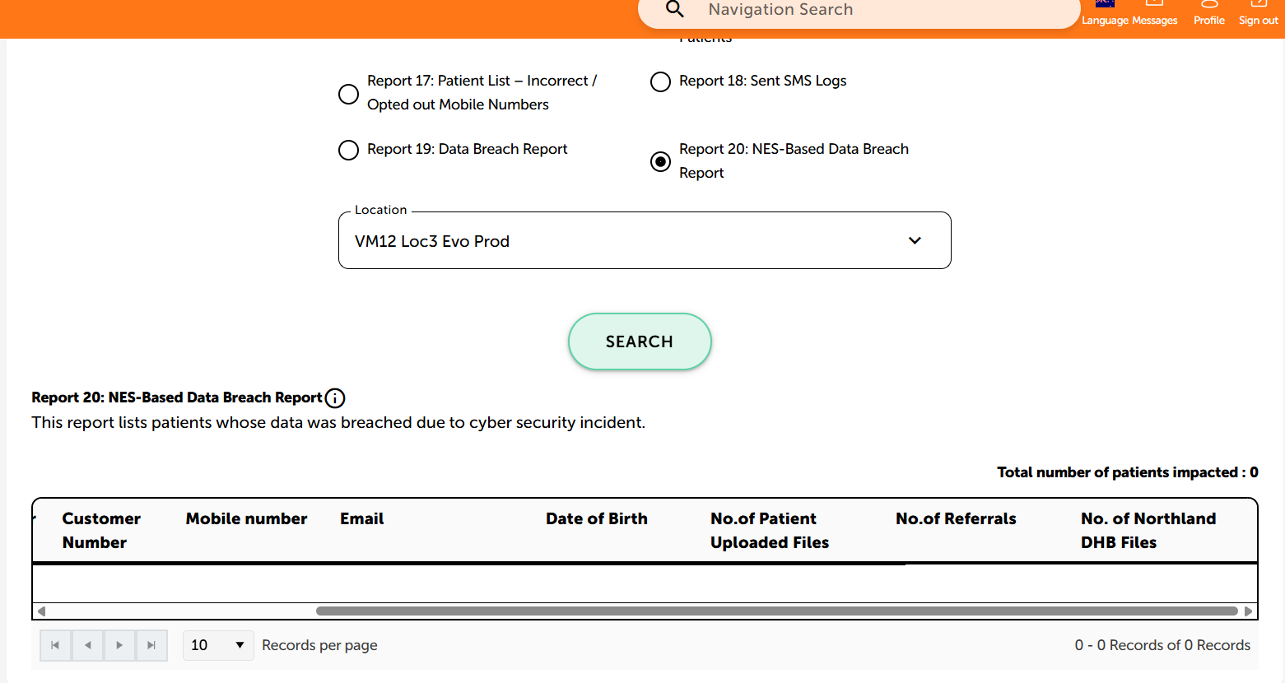
Patients in this category were not affected.

If you are still waiting for a report on an impacted patient list then please contact us. We have now confirmed that the two cohorts that are impacted are those that have uploaded documents themselves and patients who have had care with HNZ Te Tai Tokerau (Northland).

What should we do next?
We will notify impacted patients. Please continue the incredible job you are doing with patients. If patients ring needing to know their status, please direct them to log into MMH (for those that have an account).

Who is responsible for notifying and supporting impacted patients?
GP practices are not expected to notify impacted users and provide support as required.

Is it safe to continue uploading documents to MMH?
MMH has been confirmed to be safe by external international experts and confirmed by Health NZ.
The My Health Documents module was accessed but is now secure, and no other part of the application was breached.
The connection to Medtech is secure and was not part of the incident

Patient Notifications
Manage My Health is notifying affected patients. So far, all users who are adults and who have a Manage My Health account have been notified. The next cohorts to be notified will be the under16 accounts, and their linked accounts.

The next cohort to be contacted will be patients where we have contact details, but who do not have a Manage My Health account. We are creating a secure portal where these patients will be able to see the documents that were affected. This will take some time, and we do not expect to be able to notify these patients until next week when the portal is available.

Following this we will attempt to contact are patients that do not have an email address or phone number recorded with us. We are still working on how we will be able to notify these patients, and no timeline has been set.

We will also be working through notifications for patients that have been identified to us by practices – please see further clarification on vulnerable patients below.

It is important to note that there is no specific timeline by which we must provide notifications, and that at this stage these final notifications could take some weeks. We note that in the case of other healthcare breaches, notifications have taken weeks to in some cases months. We will complete this process as quickly as possible, while ensuring that we are accurate and respectful.

Further clarification regarding vulnerable patients
We recognise we could have been clearer when asking practices to identify Vulnerable patients. We have taken further guidance on grounds for withholding notifications The OPC’s view is that it would be best if notification is conducted with the appropriate support provided, rather than notification being withheld. Support is being provided via the 0800 number with the help centre able to refer patients for further support to other services if needed. . We are encouraging practices to review their list of patients who they have classed as vulnerable and resubmit NHIs to us for patients that truly meet the ‘absolutely necessary’ standard of the Privacy Act.

General Patient Enquiries

Please direct patients to:
https://managemyhealth.co.nz/faqs-cyber-breach/

How can I confirm whether my personal information has been affected?
Affected individuals will be notified as soon as it is possible to verify who is impacted, establish their identity and what data has been compromised.

If you have received a notification, login to the MMH application to see your security status. If you do not have a MMH account, when you are notified then you will receive instructions on how to securely access the information about the breach.

What if I have changed practices?
You will be contacted if you have been affected, regardless of which practice you are currently enrolled with.

How can I opt out of Manage My Health?
Sign in to the MMH app → My Account → Close Account.

What happens to my information if I leave?
Your information is deleted 72 hours after you close your account.

Impacted Patients – FAQs

How do I know which documents were accessed?
If you have an MMH account, login and you will see your security status in the top right of the screen. Click on that box to see details of documents that were accessed, if any.

If you do not have an MMH account, you will receive instructions about how to access the documents when you receive the notification.

What should I do next?
Please wait until you receive formal notification.

How do I get support?
An 0800 number is available to all impacted users. If you have been impacted you will get a notification, and the 0800 number will be in the notification. We are working as fast as we can on the notification process, which involves HealthNZ, the Privacy Commissioner and other organizations.

Can I close my account?
We appreciate this is a concerning time, however we do not recommend that you close your system at this time. Note that closing your account does not remove the patients accounts – they can still access their data through MMH. Individual users can close their accounts if they wish by going to ‘my account – close account’ in the application. MMH is an important method for communicating with patients, and we will be using MMH to communicate with affected users. If you close MMH now that will make secure communication with users much more difficult.

