Medtech quesry search for patients with FIT kits requested in May with no result in inbox

These are the search items

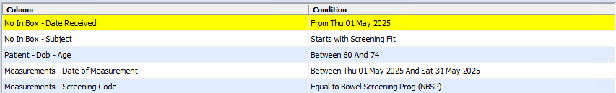

These are the report / outcome options

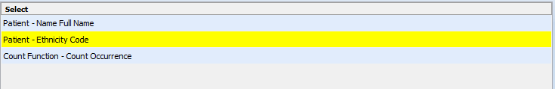

This is the SQL if preferred

SELECT

ANYBODYPAT.PREFORMATTEDEXTERN,

ETHNICITY1.CODE,

COUNT(*) COUNT1

FROM

MEASUREMENT MEASUREMENT

LEFT JOIN ANYBODYPAT ANYBODYPAT ON MEASUREMENT.PATIENTID = ANYBODYPAT.ID

AND ANYBODYPAT.ISACTIVE = 1

AND ANYBODYPAT.RowInactive = 0

LEFT JOIN vw_NullInBox NULLINBOXS ON MEASUREMENT.PATIENTID = NULLINBOXS.PATIENTID

AND NULLINBOXS.ISACTIVE = 1

AND NULLINBOXS.WHENRECEIVED >= '05/01/2025 00:00:00'

AND NULLINBOXS.SUBJECT LIKE 'Screening Fit%'

LEFT JOIN MODULESETUP ETHNICITY1 ON ETHNICITY1.ID = ANYBODYPAT.ETHCODE

LEFT JOIN SCREENINGTERM SCREENINGTERM ON MEASUREMENT.SCNID = SCREENINGTERM.ID

AND SCREENINGTERM.IsActive = 1

LEFT JOIN SCREENINGOUTCOME SCREENINGOUTCOME ON MEASUREMENT.SCNOUTCOMEID = SCREENINGOUTCOME.ID

AND SCREENINGOUTCOME.IsActive = 1

WHERE

ANYBODYPAT.RowInactive = 0

AND ( NULLINBOXS.WHENRECEIVED IS NULL

AND NULLINBOXS.SUBJECT IS NULL

AND ANYBODYPAT.YEARS BETWEEN 60

AND 74

AND MEASUREMENT.WHENMEASURE BETWEEN '05/01/2025 00:00:00'

AND '05/31/2025 23:59:59'

AND SCREENINGTERM.CODE = 'NBSP'

AND SCREENINGOUTCOME.CODE = 'C' )

AND MEASUREMENT.RowInactive = 0

AND MEASUREMENT.ISACTIVE = 1

GROUP BY ANYBODYPAT.PREFORMATTEDEXTERN,

ETHNICITY1.CODE