1. **Reports of overdue or unscreened patients NBSP.**

**Indici**

Go to Advanced Report Builder

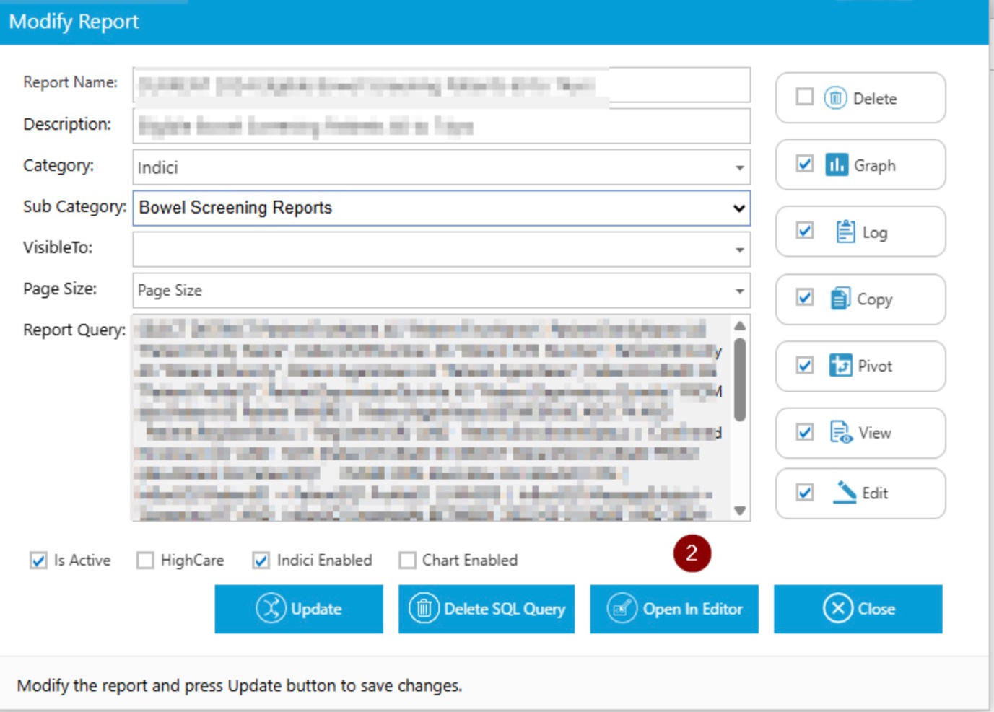

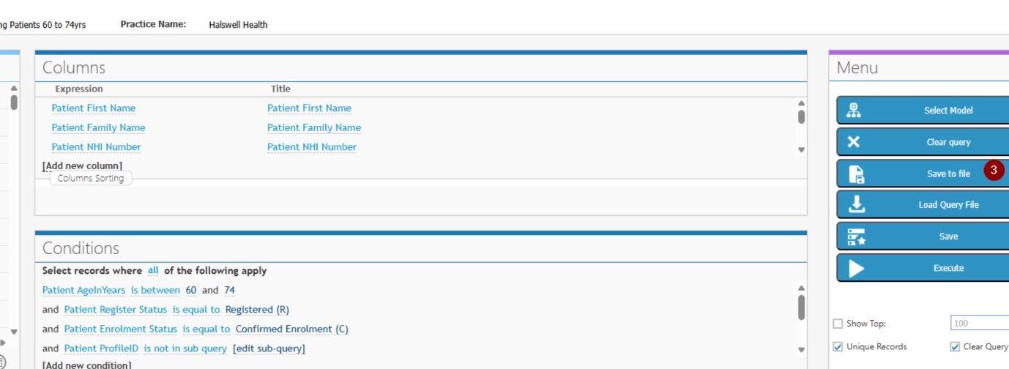

**Or**

1. Click on the Library Icon along the top right of the screen



1. Click on South practices on the left  
   Select Halswellhealth
2. Then select the 'Home' icon to the right of the report

**Medtech**

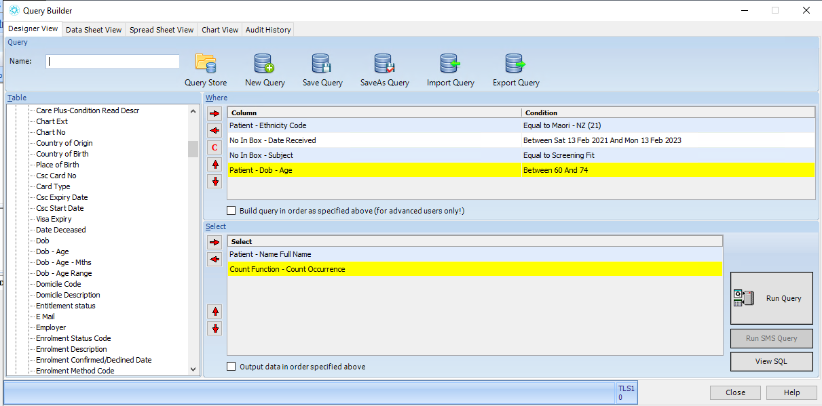

**My Practice**

1. **Audit Kits returned from practice requests via PMS**

**Medtech**

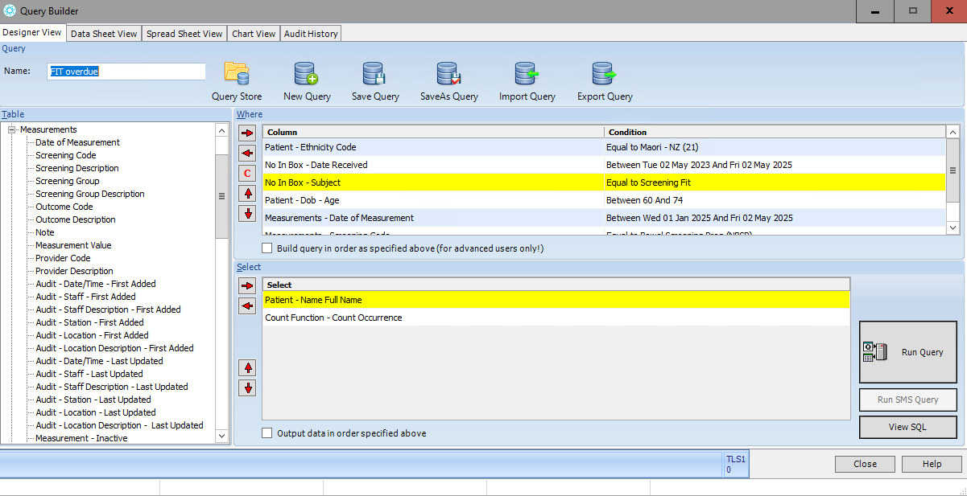

**Indici**

                      **1: *FIT Overdue - Maori*  
                      2: *FIT Overdue - Pacific***

**Common Criteria for Both Reports:**

1. The patient must be active and alive.
2. The measurement type must be "Bowel Screening".
3. The measurement must be active.
4. The bowel screening measurement must have been recorded on or after **01 May 2025**.( flexible dates )
5. The patient's age must be between **60 and 74 years**.
6. The patient must **not** have any inbox records with the subject **"Screening Fit"** that were added on or after **01 May 2025**.( flexible dates )

Go to Home - Advance Report Builder.

Click on **Report**, then navigate to the **second page**—the relevant reports can be viewed there.  
Kindly refer to the screenshot below for guidance.

